PhD Viva Voce
Candidate Name: | Wakati Maliva | 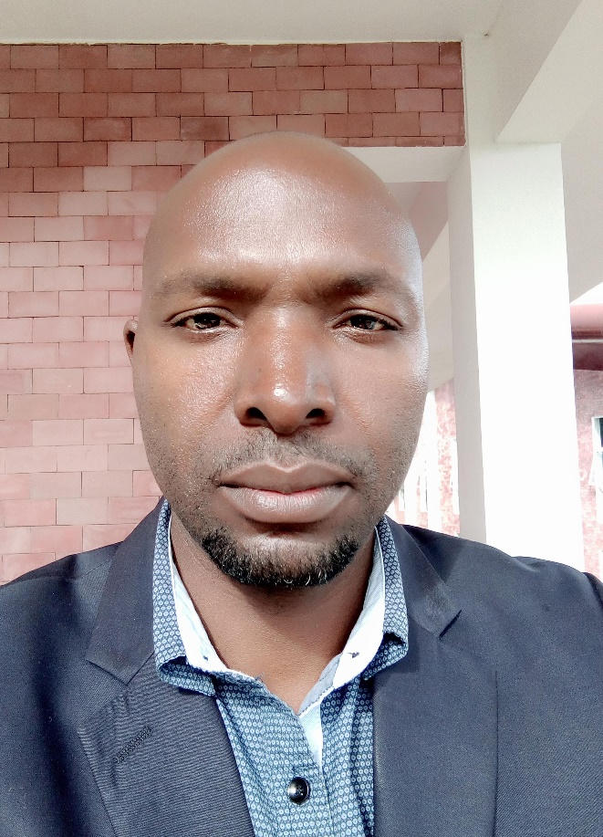
Registration Number: | 2018-07-00015
 | University of Dar es Salaam
 | School of Education

Qualifications Attained:
Mr. Maliva is a PhD candidate by Coursework and Dissertation in the Department of Educational Psychology and Curriculum Studies, School of Education at the University of Dar es Salaam (UDSM). He is also a teaching staff at Mkwawa University College of Education since 2010. Mr. Maliva completed his first degree, a Bachelor of Education in Arts, from UDSM in 2009. He later progressed to a Master of Arts in Education degree programme in 2011 and completed it in 2013 from the same university. Mr. Maliva teaches several courses including Teacher Education English Methods, Secondary Education Language Methods, Classroom Interaction and Research, and Principles of Curriculum Development and Teaching. Mr. Maliva’s research interests include Language Development, Language in Education, Language Assessment and Foreign Language Learning.

Title of Thesis: | Teachers’ Classroom Practices in the Assessment of English Oral Language Skills in Secondary Schools in Tanzania
Date of Viva Voce: | 14th February, 2024
Venue: | Board Room-SoED
Time: | 10: 00a.m
Supervisors: | Dr. Mwajuma Vuzo and Dr Orestes Kapinga

Abstract:
This study investigated teachers’ classroom practices in the assessment of English oral language skills in secondary schools in Tanzania. The study was set to address three research objectives namely, to examine English Language Teachers (ELTs) understanding of oral language assessment in English language subject; to evaluate ELTs’ classroom assessment practices of oral language skills conducted in secondary schools; and to explore challenges ELTs’ experience in assessing oral language skills in English language subject. The study was informed by Sociocultural theory. The study used the interpretivist research paradigm and qualitative research approach. Moreover, the study used a case study design where the sample of the study was eight (8) teachers. Schools and teachers were obtained through criterion sampling. Data were collected through interviews, classroom observations and documentary reviews. Findings revealed that classroom oral language assessment was more or less uniformly understood by ELTs. Preparation of schemes of work indicated that ELTs were enthusiastic to conduct oral language assessment particularly through questions and answers. Findings further revealed that oral language skills were assessed mainly through questions and answers, group discussions, speaking tasks and listening tasks. ELTs’ willingness to assess oral language skills was held back by classroom environment where large classes, insufficient teaching and learning resources, shortage of time and lack of in-service training were the leading factors. It is concluded that ELTs’ assessment practices moderately promote students’ oral language skills in English as students do not get enough opportunity to practice oral language in the presence of ELTs for assessment. ELTs’ oral language assessment practices were affected by environmental factors. Underrepresentation of oral language assessment result into failure to attain one of the main objectives of teaching language stated in the syllabus; ability to communicate orally with other speakers of English. The study recommends: maintaining the recommended class sizes; inclusion of oral language assessment in the high stakes examinations and provision of in-service training to teachers in order to improve classroom oral language assessment practice. Furthermore, to develop oral language proficiency among students, ELTs need to create more opportunities for students to practice oral language skills, particularly speaking.
Panel Members
No | Name | Designation | Rank | Unit
 | Prof. Abel Ishumi | Chairperson | Professor  Emeritus | SoED-EFMLL
 | Dr. Septimi Kitta | Representing External Examiner | S/Lecturer | SoED-EPCS
 | Dr. Jafari Abdala | Internal Examiner | Lecturer | SoED-EPCS
 | Dr. Mwajuma Vuzo | Candidate’s Supervisor | S/Lecturer | SoED-EPCS
 | Dr. Albert Tarmo | Head of the relevant department (or his/her appointee) | S/Lecturer | SoED-EPCS
 | Dr. Elizabeth Gwajima | Co-opted Member (appointed by College/School/Institute | Lecturer | SoED-EPCS
 | Dr. Fortunatha Matiba | Co-opted Member (appointed by College/School/Institute | S/Lecturer | SoED-EFMLL
 | Dr. Cyprian Kilangi | Appointee of the Principal for PhD only) | S/Lecturer | CoHU

